**Year 8 Biology End of Topic Test**

**Name: ______________________________________**

Multiple Choice Answer Sheet

1. A B C D 16. A B C D

2. A B C D 17. A B C D

3. A B C D 18. A B C D

4. A B C D 19. A B C D

5. A B C D 20. A B C D

6. A B C D

7. A B C D

8. A B C D

9. A B C D

10. A B C D

11. A B C D

12. A B C D

13. A B C D

14. A B C D

15. A B C D

**Multiple Choice**

**1.** The simplest units of life that we could call alive are:

a. atoms

b. cells

c. molecules

d. proteins

**2.** The main purpose of respiration in organisms is:

a. to produce carbon dioxide

b. so that plants can breathe

c. to remove oxygen from the atmosphere

d. to produce energy

**3.** Which of the following lists contain only examples of mechanical digestion?

a. Chewing in the mouth and the churning by stomach muscles.

b. Chewing in the mouth, protease break down of proteins.

c. Churning by the stomach muscles and protease break down of proteins.

d. Protease break down of proteins is the only example.

**5.** Which of these statements about the equation below is **INCORRECT**:

[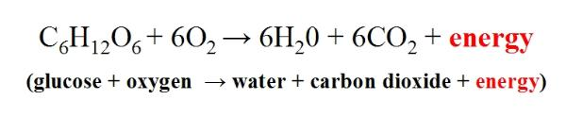](http://www.google.com.au/url?sa=i&rct=j&q=&esrc=s&frm=1&source=images&cd=&cad=rja&docid=zISSTtDQqk4lVM&tbnid=CiDE1YE4C7BFfM:&ved=0CAUQjRw&url=http://cronodon.com/BioTech/Respiration.html&ei=BjzIUaLLLIrakAWNjIGQBQ&bvm=bv.48293060,d.dGI&psig=AFQjCNHWDWbN0w1PaKgMe-_x2xQtW0lWaQ&ust=1372163451373414)

1. The glucose comes from the digestive system
2. This is the equation for cellular respiration
3. The oxygen enters the body through the heart
4. The carbon dioxide is removed from the body in the alveolus

**6.** In which of the following does the exchange of oxygen between the blood and body cells occur?

1. Arteries.
2. Platelets.
3. Veins.
4. Capillaries.

**7.** Which of the following is NOT correct about breathing in?

1. The diaphragm contracts and moves down.
2. The diaphragm contracts and moves up.
3. The rib cage moves up and out.
4. The spongy tissue of the lungs expands.

**8.** The alveoli are which of the following?

1. Hairlike structures lining the trachea and bronchus.
2. The muscle between the ribs.
3. The tube leading from the mouth to the lungs.
4. Small air sacs in the lungs, needed for gas exchange.

**9.** Which of the following shows the correct order of structures that air would pass through as it was breathed in?

1. Alveoli, mouth, bronchioles and bronchus.
2. Diaphragm, bronchioles, trachea and mouth.
3. Mouth, trachea, bronchus, bronchioles and alveoli.
4. Mouth, trachea, bronchioles, bronchus and diaphragm.

**10.** Which of the following is the reason that the heart is classified as an organ?

1. It is a group of different tissues working together to do a particular function.
2. It is made of a group of cells working together to do a particular function.
3. It has a function that is vital for life.
4. It is part of a larger system.

**11.** Where does respiration happen?

1. In all living cells.
2. In the lungs.
3. In the heart.
4. In the blood.

**12.** The intercostal muscles are found:

1. Under the lungs.
2. Between the ribs.
3. In the heart.
4. Lining body organs.

Look at the diagram below and use it to answer the next 4 questions.

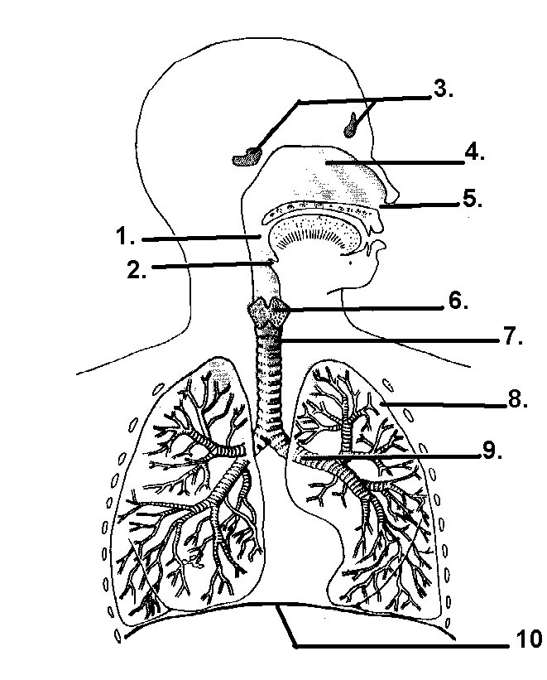

**13.** In the diagram, structure 10 is the:

1. Bronchus
2. Intercostals muscles.
3. Pleural membrane.
4. diaphragm.

**14.** In the diagram, structure 9 is:

1. Trachea.
2. Intercostals muscles.
3. Bronchus
4. diaphragm.

**15.** The function of structure 2 is:

a. To stop the trachea from collapsing when the neck is bent or a person breathes in.

b. Allows a person to speak.

c. Warms the air before it enters the lungs.

d. Prevents food entering the lungs.

**16.** Which of the following statements is correct?

a. Structure 9 is the trachea

b. Structure 7 is the trachea

c. Structure 9 is a Bronchus

d. Structure 9 is a Bronchiole

**17.** The backflow of blood between the ventricles and the atria is prevented by which of the following?

1. Cardiac muscles.
2. Tendons.
3. Valves.
4. Veins.

**18.** Which one of the following statements is **true?**

1. The left ventricle wall is thicker than the right ventricle wall because it must pump blood a greater distance.
2. The right ventricle wall is thicker than the left ventricle wall because it must pump the blood a greater distance.
3. The left ventricle wall is thicker than the right ventricle wall as it must withstand greater blood pressure.
4. The right ventricle wall is thicker than the left ventricle wall as it must withstand greater blood pressure.

**19.** The muscle wave that helps move food through the oesophagus, is called:

1. Sphincter.
2. Peristalis.
3. Mechanical digestion.
4. Villi.

**20.** Absorption of water in the digestive system occurs in which of the following organs?

1. stomach.
2. large intestine.
3. liver.
4. anus.

**SHORT ANSWER SECTION**

**1. A** The small intestine increases its surface area in two ways. What are those two ways?

2 marks

**B** Why is it important for the small intestine to have a large surface area?

1 mark

2**.** Do **NOT** label this diagram, just use it to fill in the table below

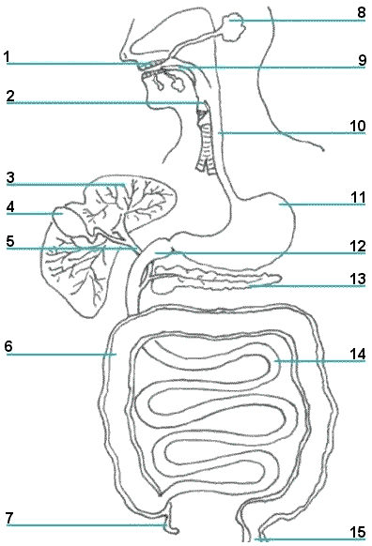

|  |  |  |
| --- | --- | --- |
| **Number** | **Name of structure** | **Function** |
| **6** |  |  |
| **10** |  |  |

(4marks)

4 marks

**3.** Do NOT label this diagram. Just use it to answer the questions below

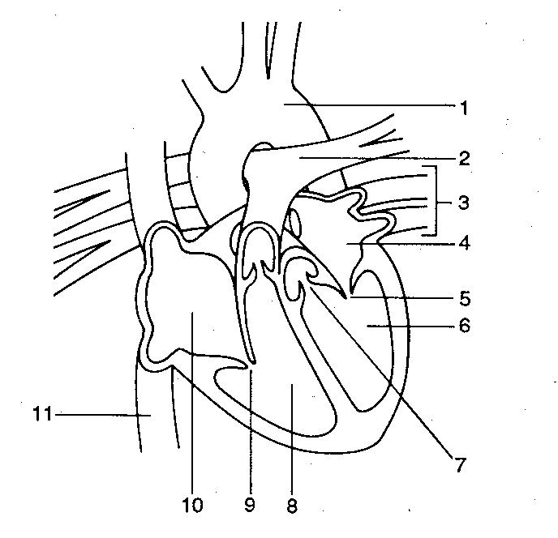

Use **red arrows to show the direction of oxygenated blood** through the heart and **blue arrows to show the flow of deoxygenated blood** through the heart. If you use different colours please use a key to show what the colours mean.

|  |  |  |
| --- | --- | --- |
| **Number** | **Name** | **Function** |
|  |  | Takes deoxygenated blood to the lungs |
|  | Aorta |  |
| 8 |  | No need to fill in this box |
|  |  | Brings deoxygenated blood to the heart from the lower body |

7 marks

**END OF TEST**